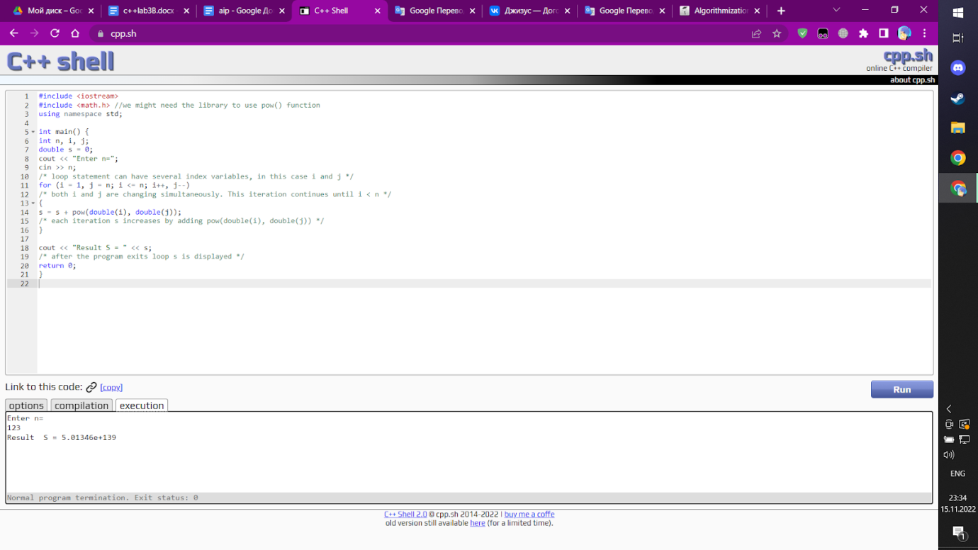1

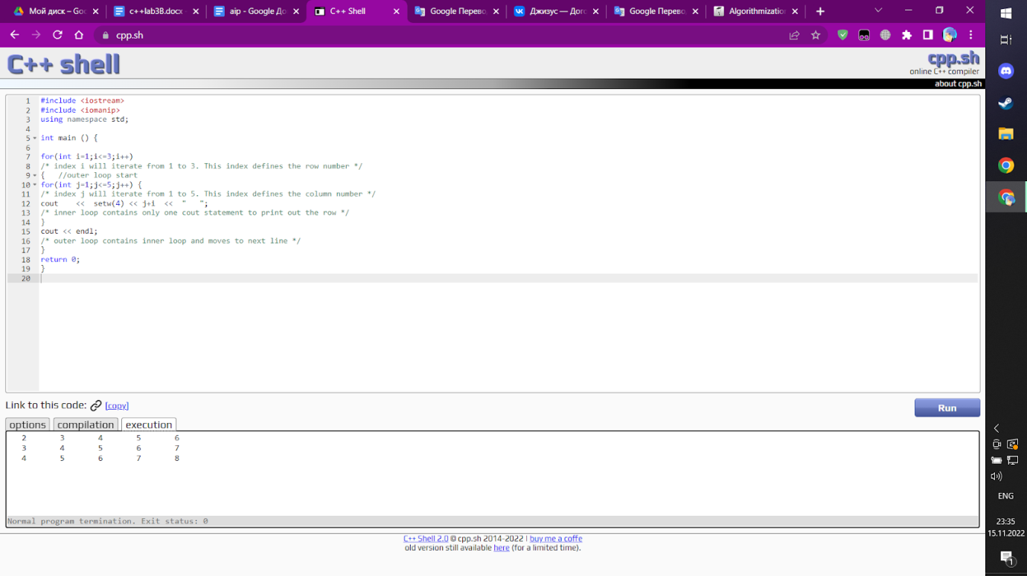2

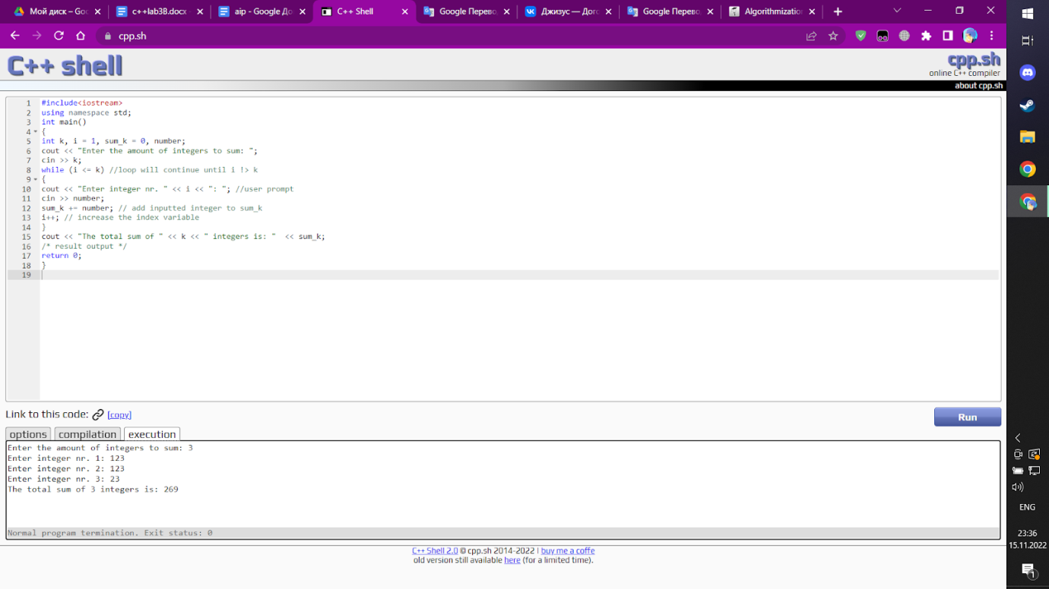3

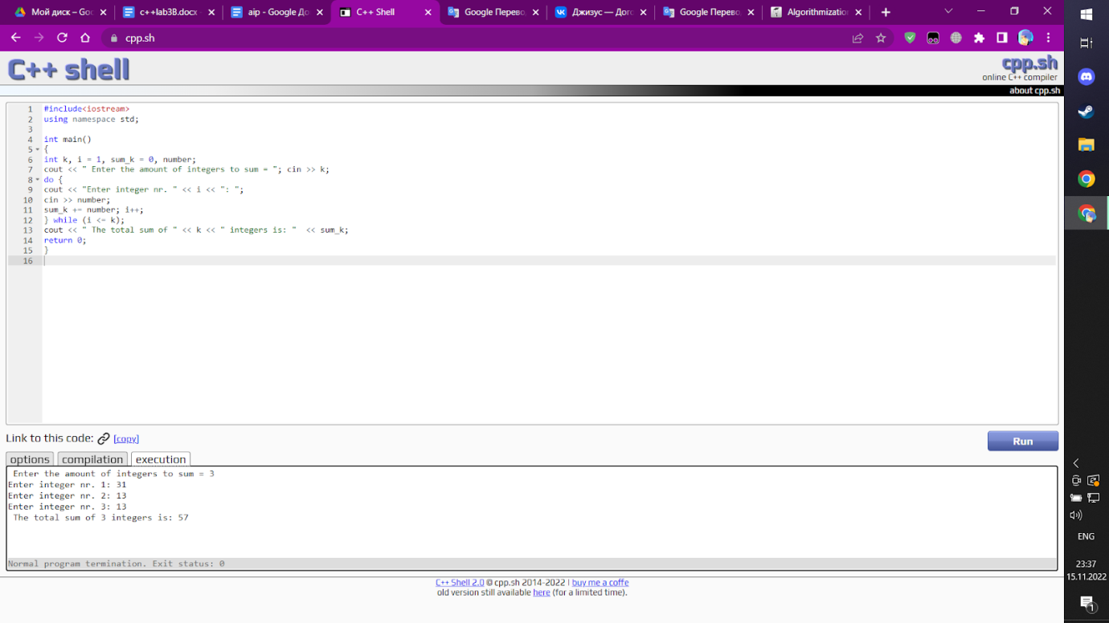4.1 (i screened it after i have ended lab , its my classical experience)

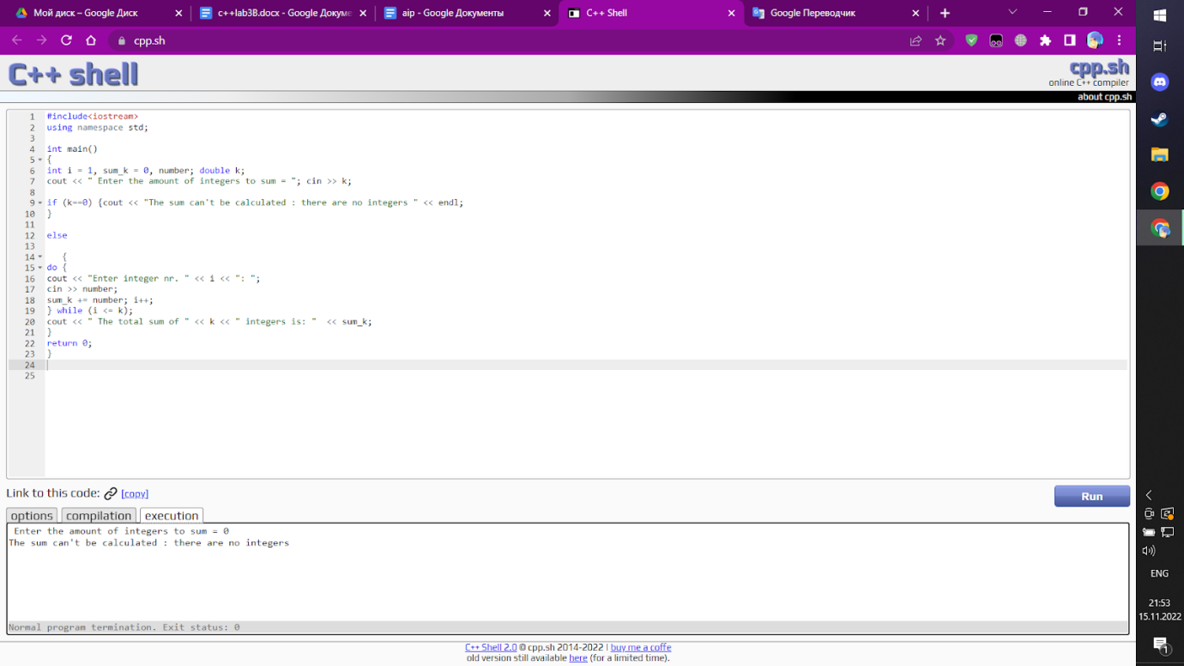4.2

#include<iostream>

using namespace std;

int main()

{

int i = 1, sum_k = 0, number; double k;

cout << " Enter the amount of integers to sum = ";

cin >> k;

if (k==0) {cout << "The sum can't be calculated : there are no integers " << endl; //first situation  // if k = 0

}

else //another situation

   {

do {

cout << "Enter integer nr. " << i << ": ";

cin >> number;

sum_k += number; i++; //total sum

} while (i <= k);

cout << " The total sum of " << k << " integers is: "  << sum_k;

}

return 0;

}

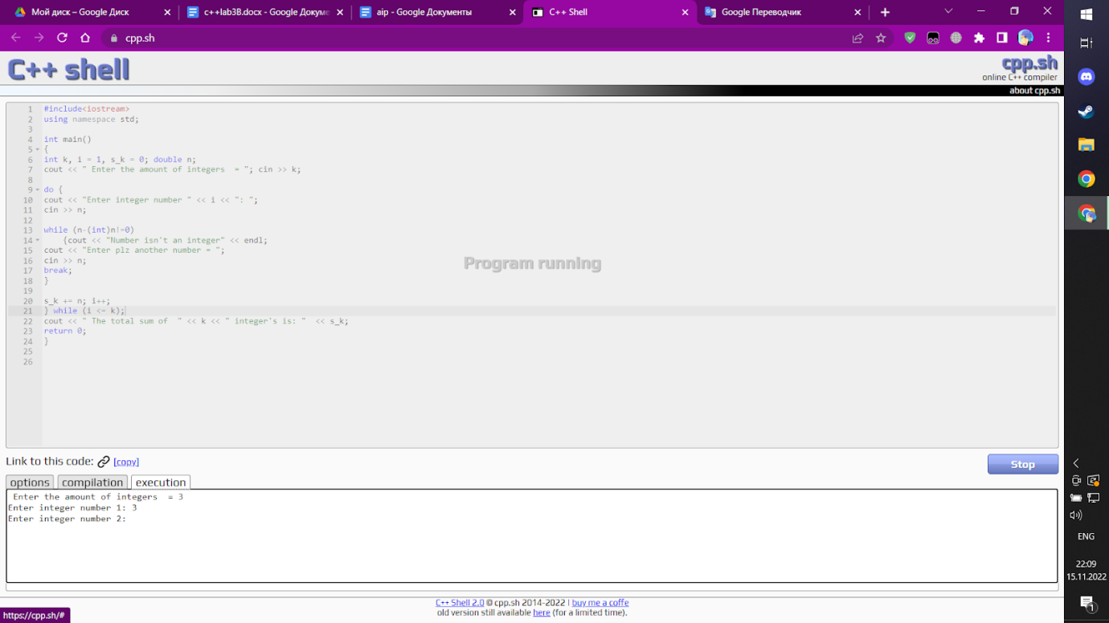4.3

#include<iostream>

using namespace std;

int main()

{

int k, i = 1, s_k = 0; double n;

cout << " Enter the amount of integers  = ";

cin >> k;

do {

cout << "Enter integer number " << i << ": ";

cin >> n;

while (n-(int)n!=0) //cheking if n is an integer

    {cout << "Number isn't an integer" << endl;

cout << "Enter plz another number = ";

cin >> n;

break;

}

s_k += n; i++; ;; calculating the sum of integers

} while (i <= k);

cout << " The total sum of  " << k << " integer's is: "  << s_k;

return 0;

}

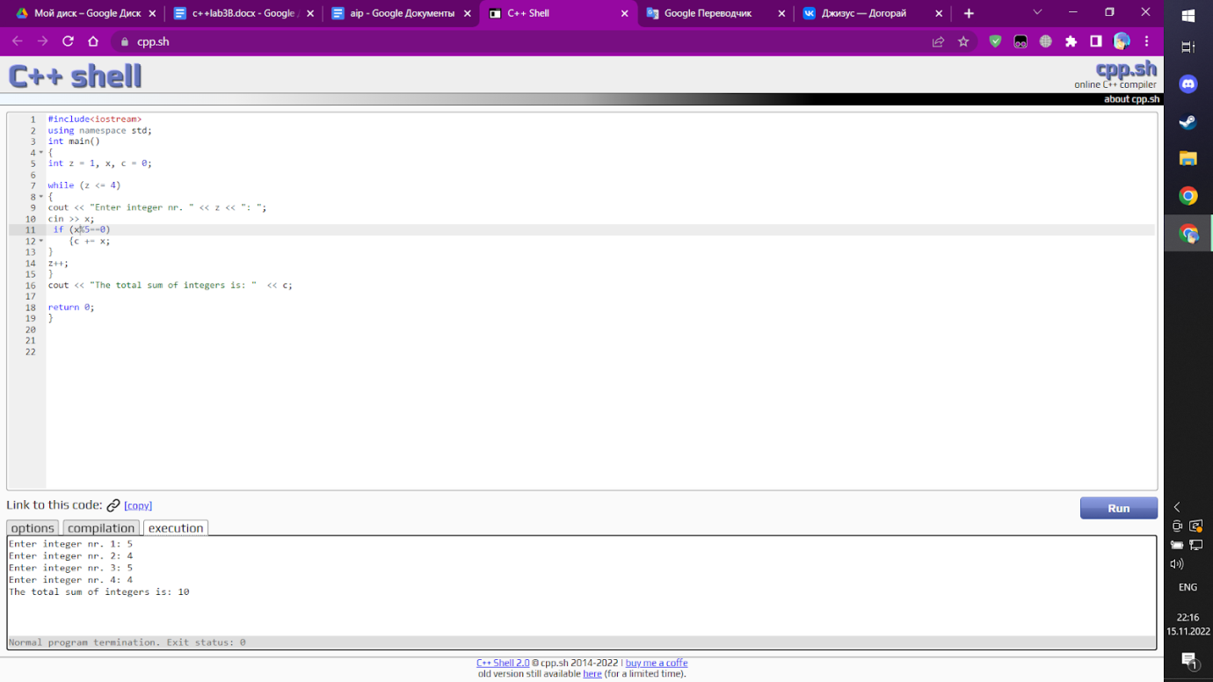5.1

#include<iostream>

using namespace std;

int main()

{

int z = 1, x, c = 0;

while (z <= 4)

{

cout << "Enter integer nr. " << i << ": ";

cin >> x;

 if (xr%5==0) // operation only for numbers which can be divided by 5

    {c += x;

}

i++;

}

cout << "The total sum of integers is: "  << sum;

return 0;

}

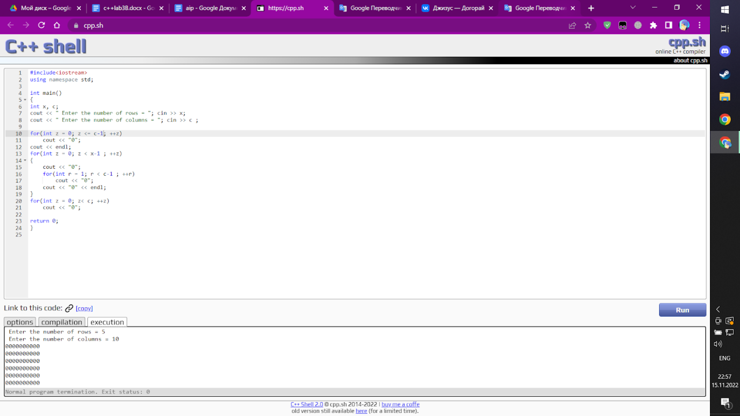5.2

#include<iostream>

using namespace std;

int main()

{

int x, c;

cout << " Enter the number of rows = "; cin >> x;

cout << " Enter the number of columns = "; cin >> c ;

for(int z = 0; z < c; ++z) // first row

    cout << "0";

cout << endl;

for(int z = 0; z < x - 2; ++z) // middle rows

{

    cout << "0";

    for(int r = 0; r < c - 2; ++r) // colomns

        cout << " ";

    cout << "0" << endl;

}

for(int z = 0; z< c; ++z)//last row

    cout << "0";

return 0;

}

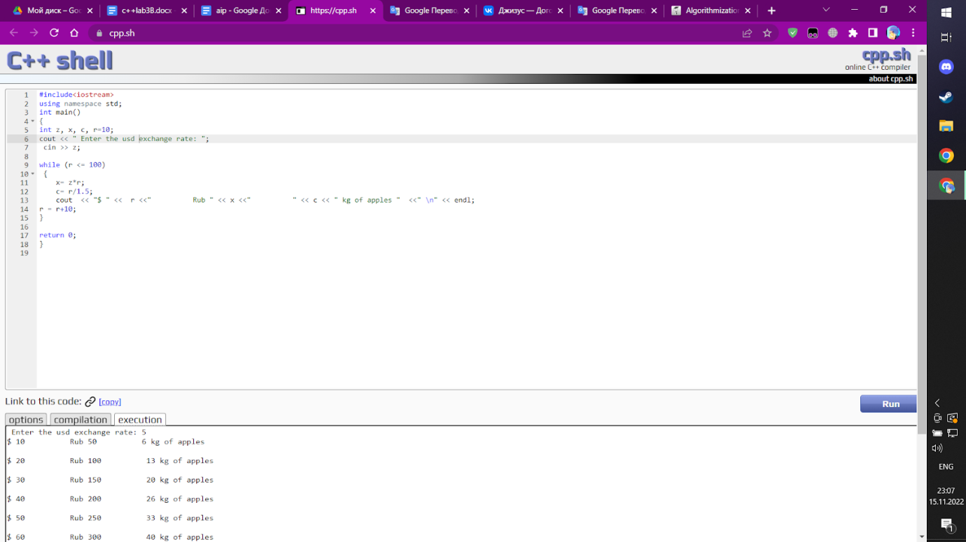5.3

#include<iostream>

using namespace std;

int main()

{

int z, x, c, r=10;

cout << " Enter the usdexchange rate: ";

 cin >> z;

while (r <= 100) // all dollars <=100

 {

    x= z*r; // calculating rubles

    c= r/1.5;//calculating amount of apples

    cout  << "$ " <<  r <<"          Rub " << x <<"          " << c << " kg of apples "  <<" \n" << endl; // table

r = r+10; // increasing dollar amount by 10

}

return 0;

}

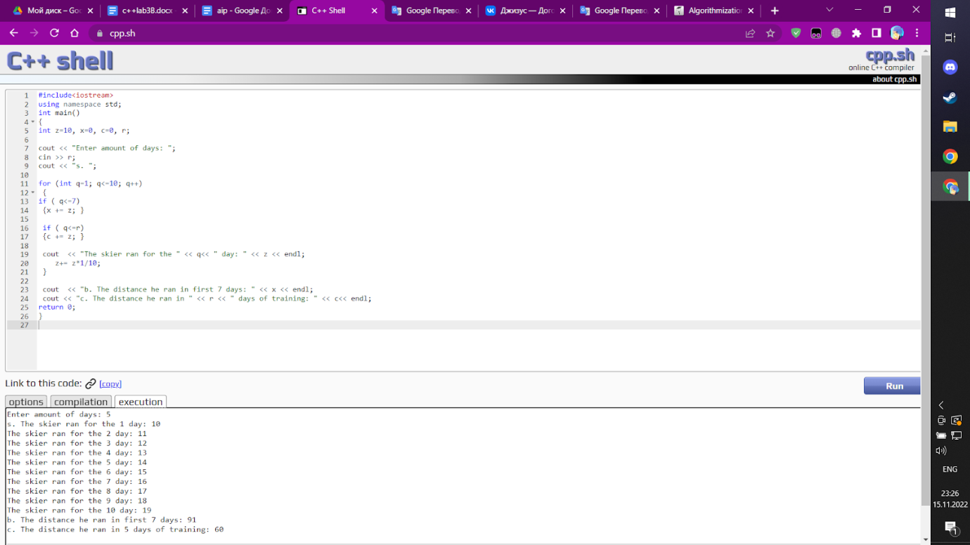5.4(a,b)

#include<iostream>

using namespace std;

int main()

{

int z=10, x=0, c=0, r;

cout << "Enter amount of days: ";

cin >> r;

for (int q=1; q<=10; q++) //days from 1-10

 {

if ( q<=7)

 {x += z; }

 if ( q<=r) //if there are less or equal days than 1

 {c += z; }

 cout  << "The skier ran for the " << q<< " day: " << z << endl;

    z+= z*1/10;

 }

 cout  << "b. The distance he ran in first 7 days: " << x << endl;

 cout << "c. The distance he ran in " << r << " days of training: " << c<< endl;

return 0;

}

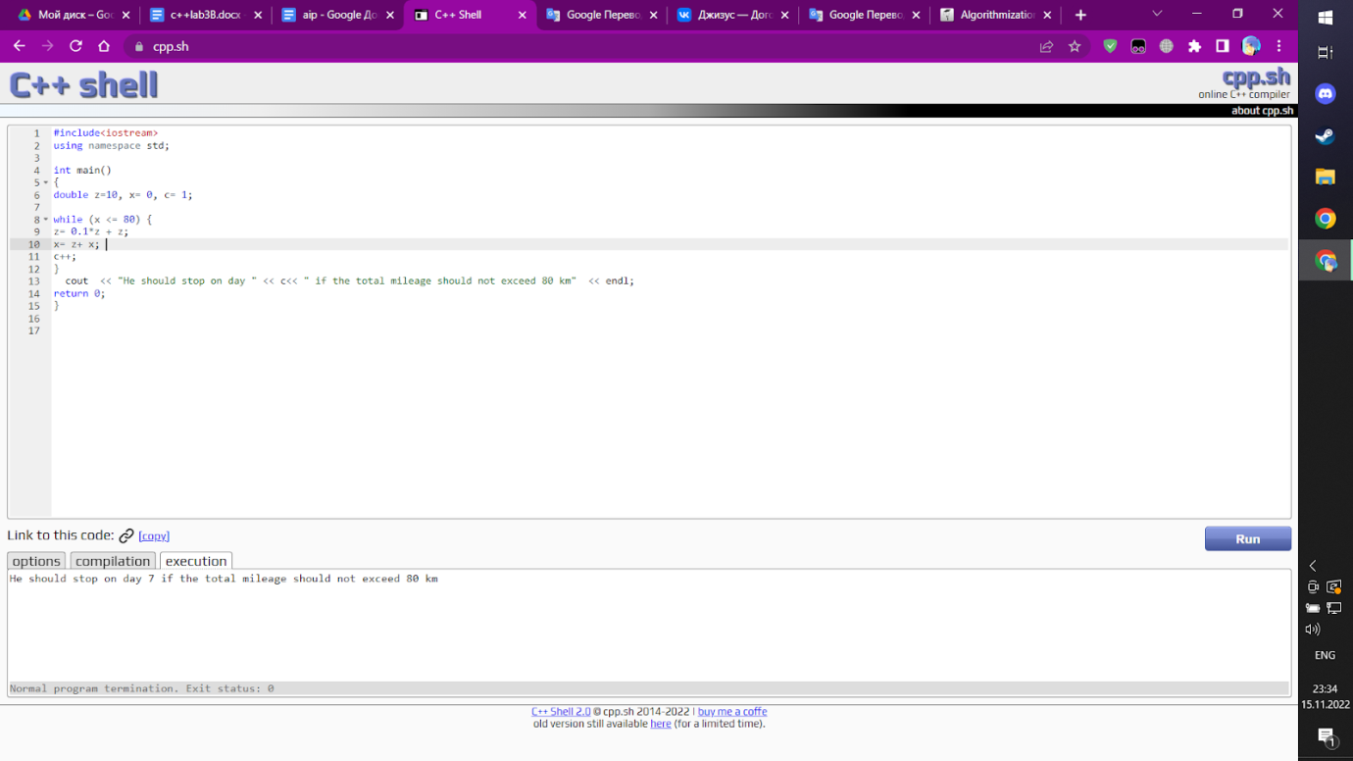5.4(d)

#include<iostream>

using namespace std;

int main()

{

double z=10, x= 0, c= 1;

while (x <= 80) { // calculating the amount of days where he can go less then 80 km

z= 0.1*z + z; //his distance daily

x= z+ x; // new distance = previos distans + new distance

c++; // ca;culating days

}

  cout  << "He will stop on the " << c<< " day  if he down want to go more than  80 km"  << endl;

return 0;

}

6.The lab was wery interesting , sorry for short comment , I started to do lab too late , but task with skier and dollar course were realy interesting(question about 5.3 : user should enter a dollar course or it should be constant ?)